**1.Create VPC with 2 private and 2 public subnets**.

Go to VPC services-🡪 click create vpc

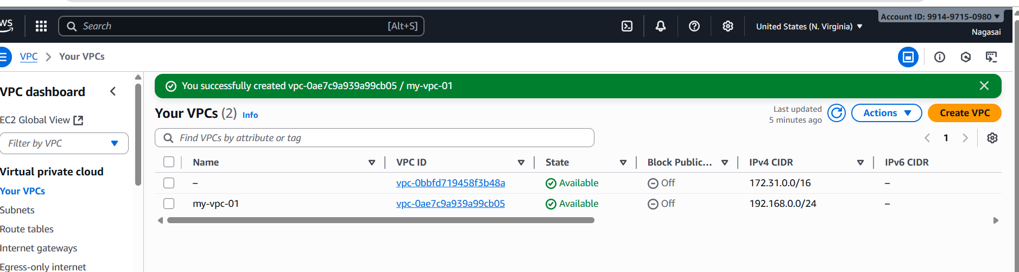

Create 2 public subnet and 2 private subnets

Go to vpc-🡪click on subnet 🡪create subnet-🡪add public subnet1🡪create public subnet.

Also, similarly add 2 private subnet and create subnet.

* **Public Subnet 1 (AZ1)** → 192.168.0.0/28

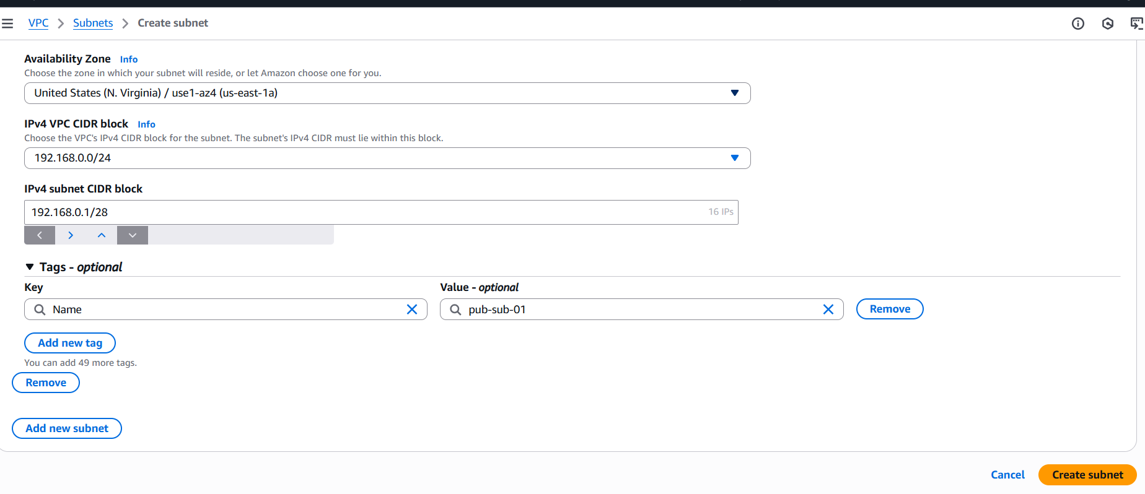

* **Public Subnet 2 (AZ2)** → 192.168.0.1/28

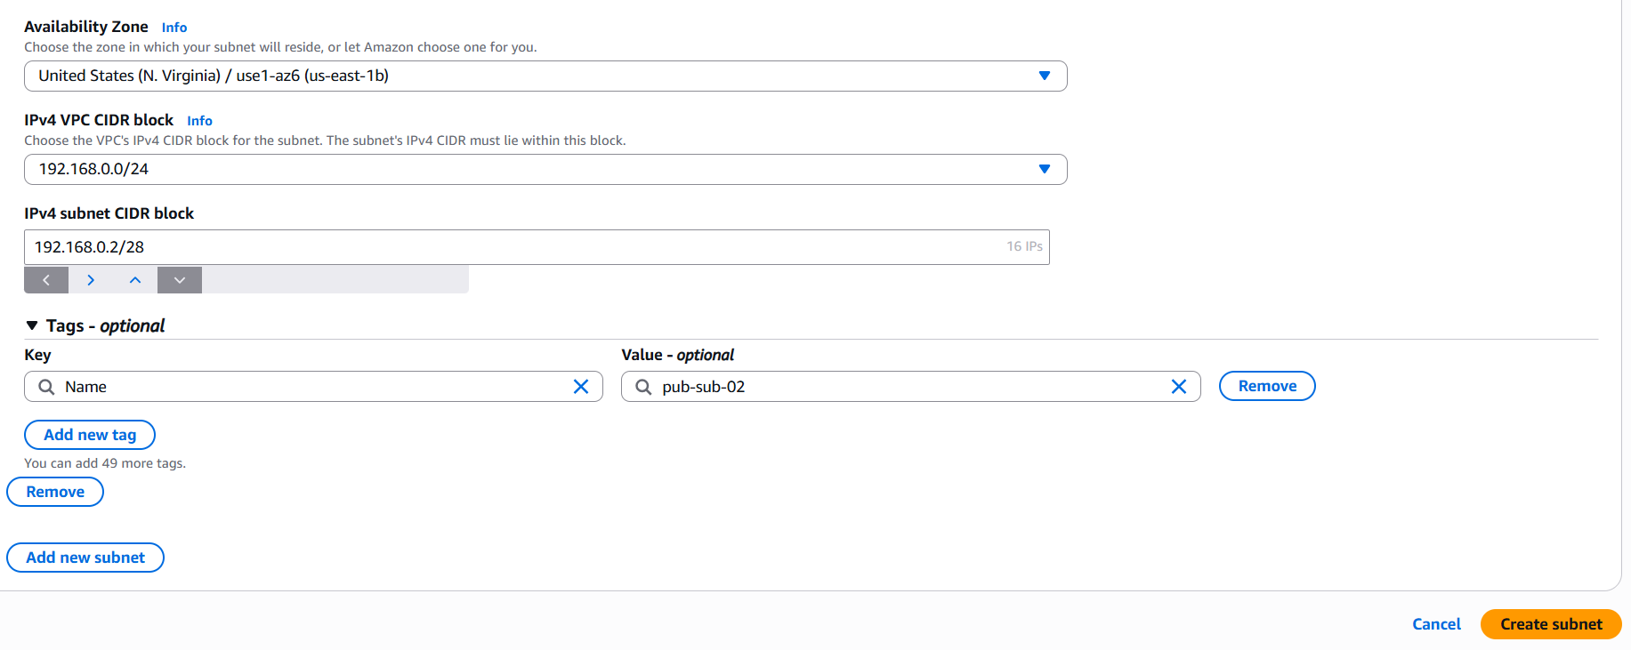

* **Private subnet1 (AZ1)** → 192.168.0.63/28

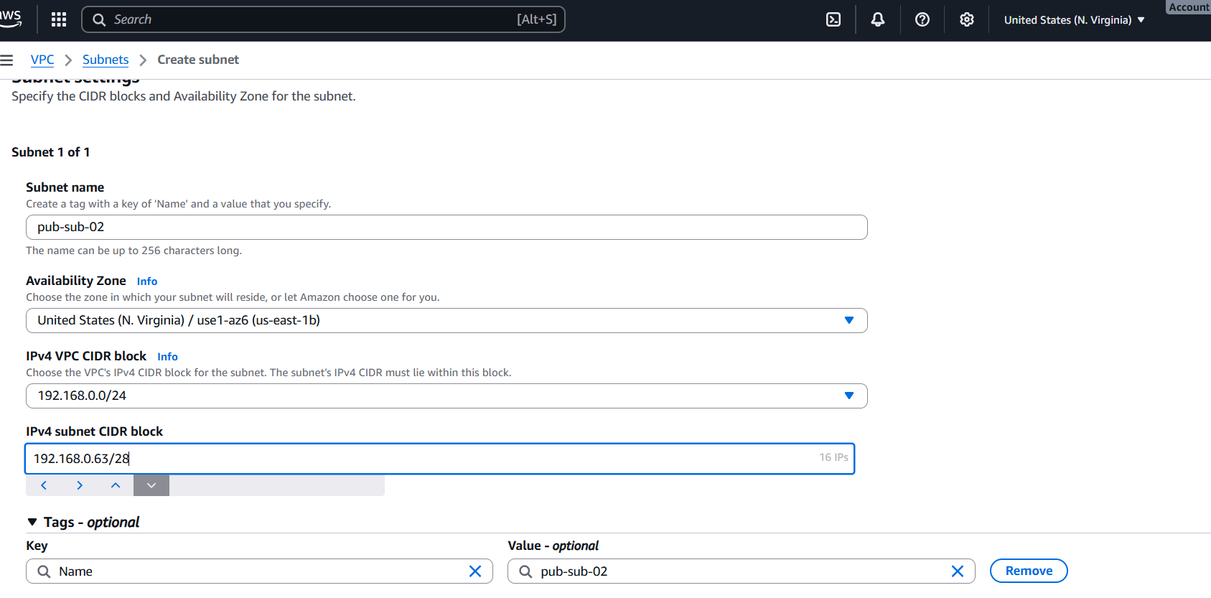

* **Private Subnet 2 (AZ2)** → 192.168.0.128/28

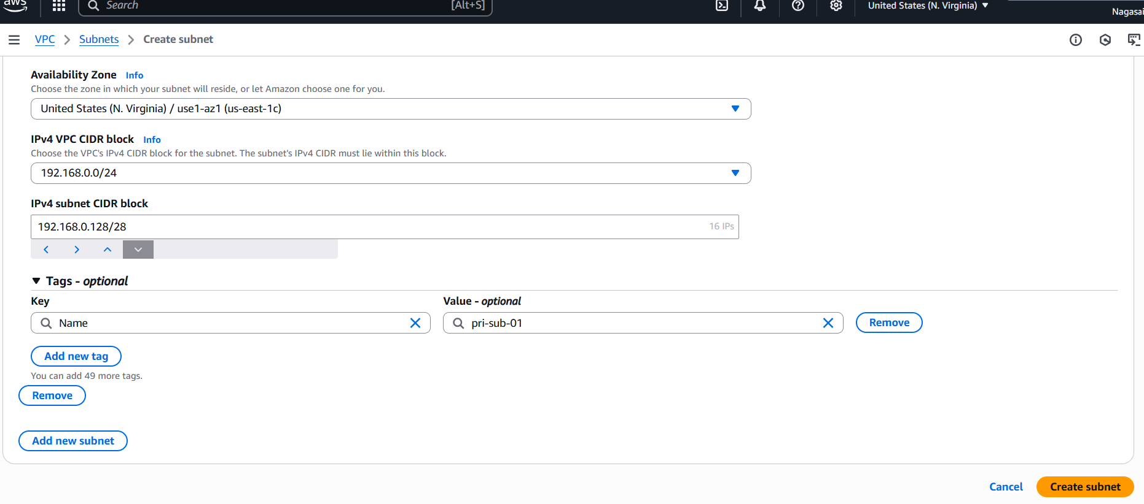

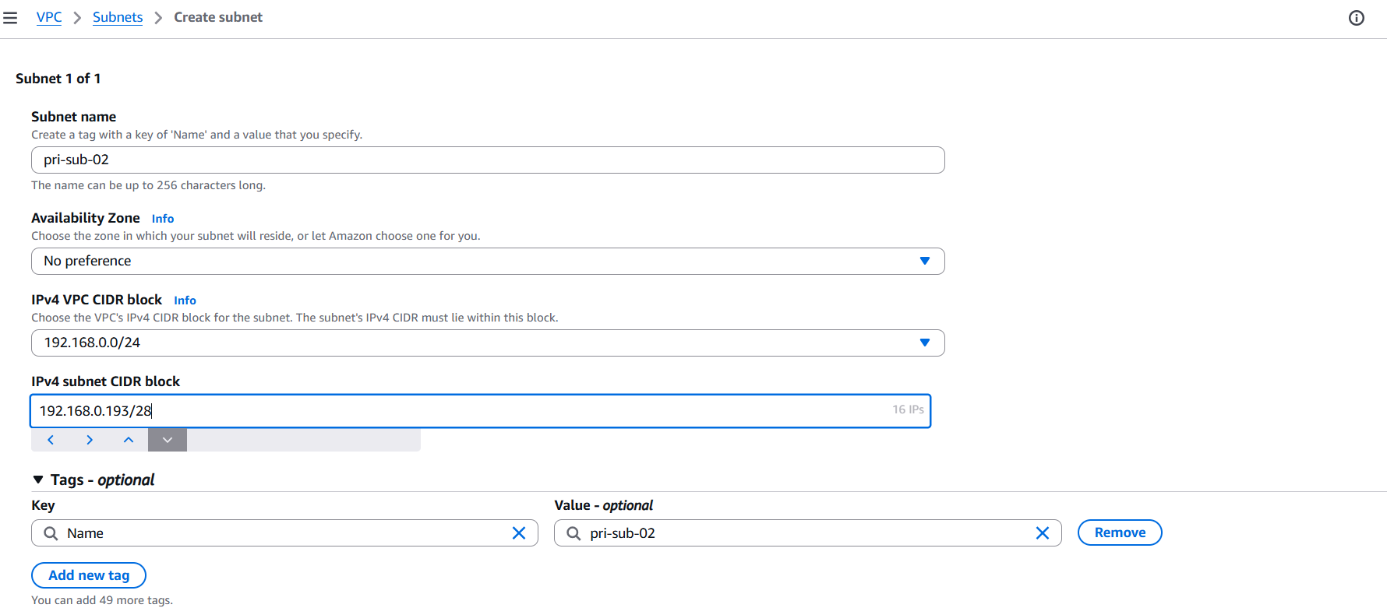

**2.Enable DNS Hostname in VPC.**

Actions → Edit VPC settings

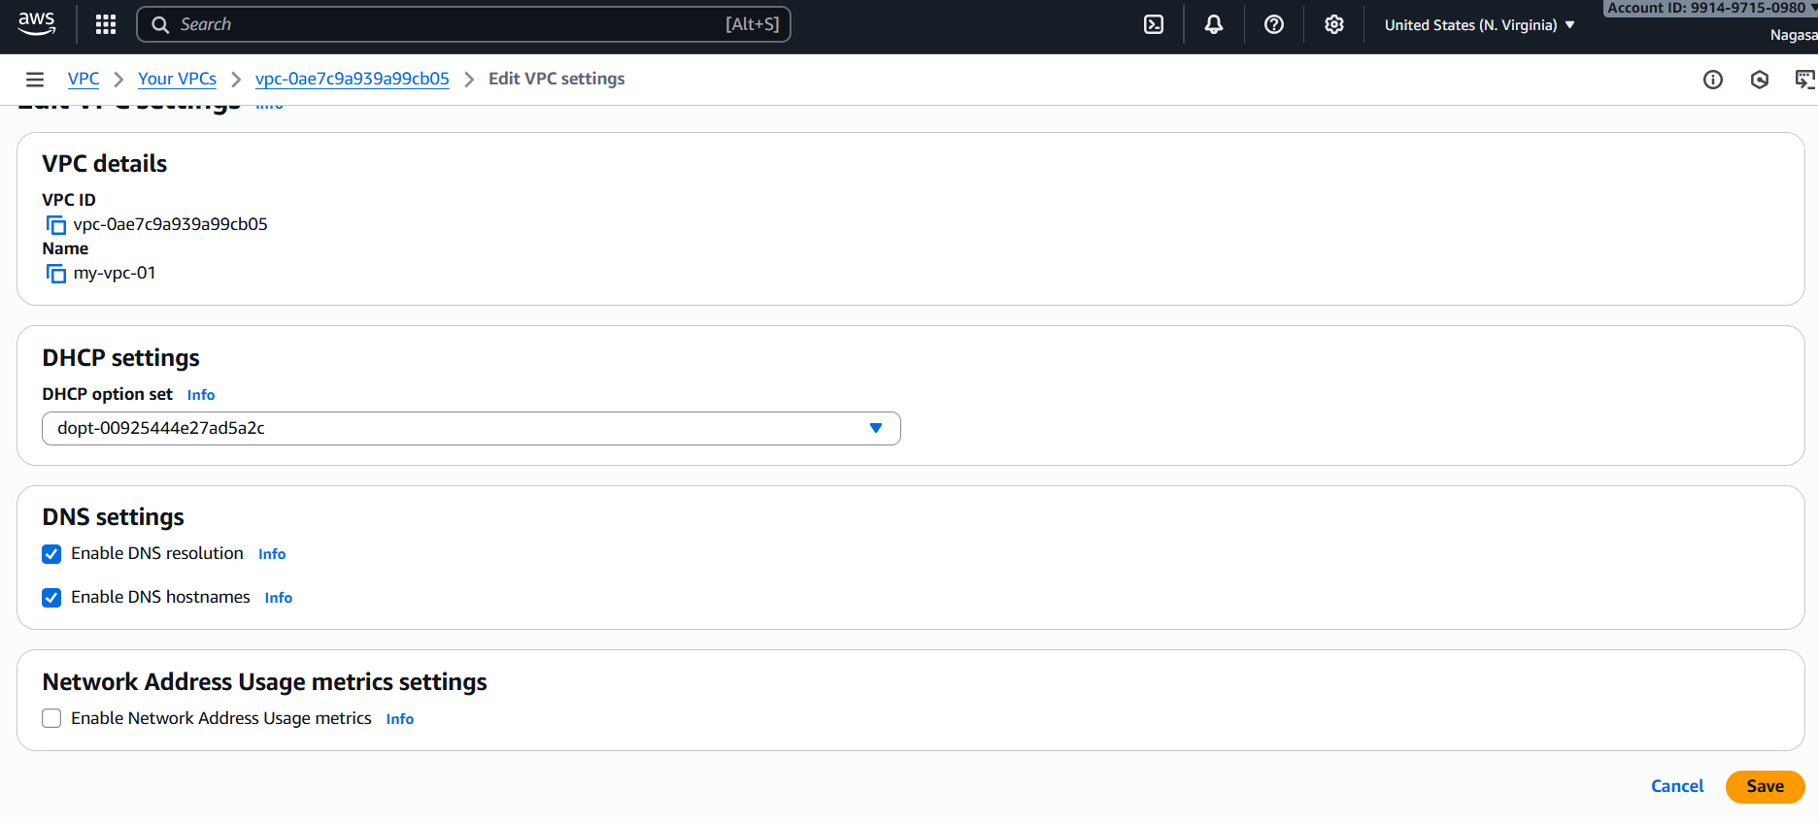

Dns settings-🡪 enable dns hostname.

**3. Enable Auto Assign Public IP in 2 public subnets.**

Go to vpc services 🡪click on subnet🡪edit subnet settings🡪enable auto assign ip settings.

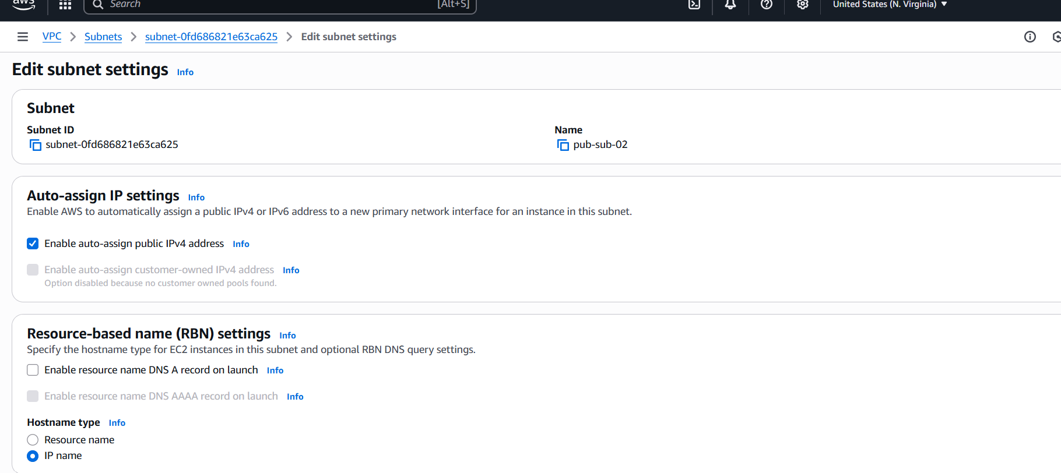

**4. Add 2 private subnets in private route table.**

For that u have to create a route table. Go to route🡪create roue table.

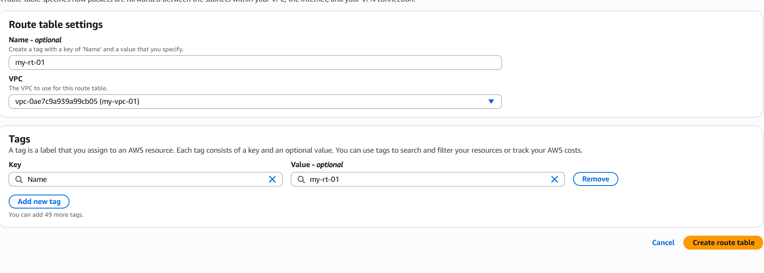

Go to route table -🡪add 2 private subnets 🡪click on edit subnet associations-🡪save associations.

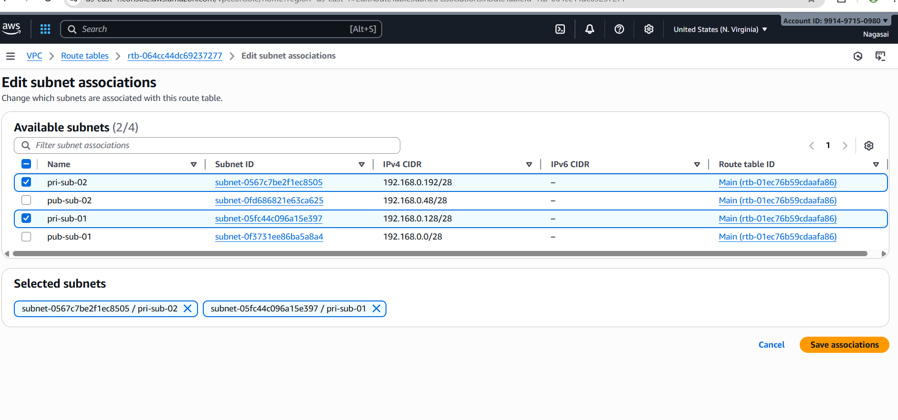

1. **Add 2 public subnets in public route table.**

Also, similarly add 2 public subnets

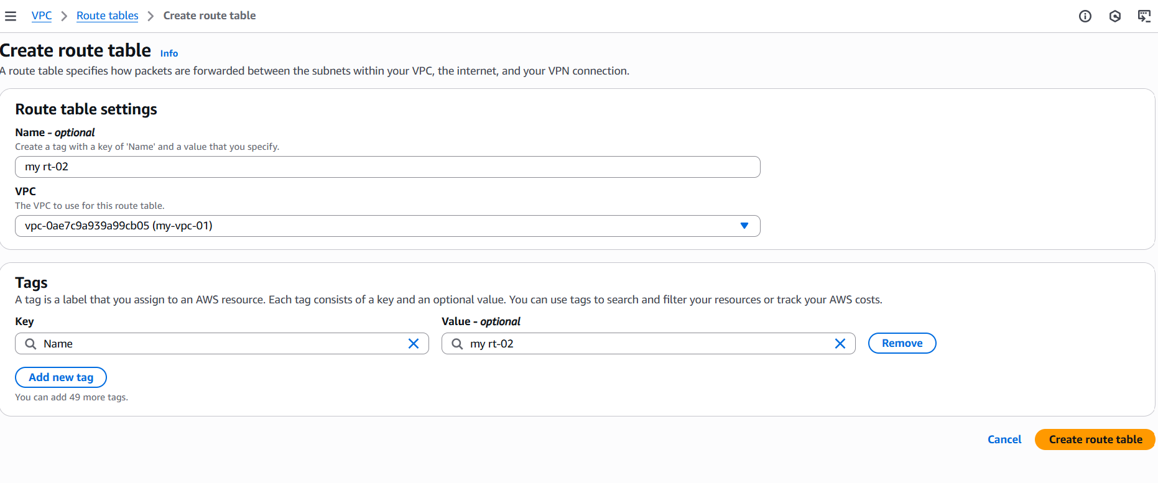

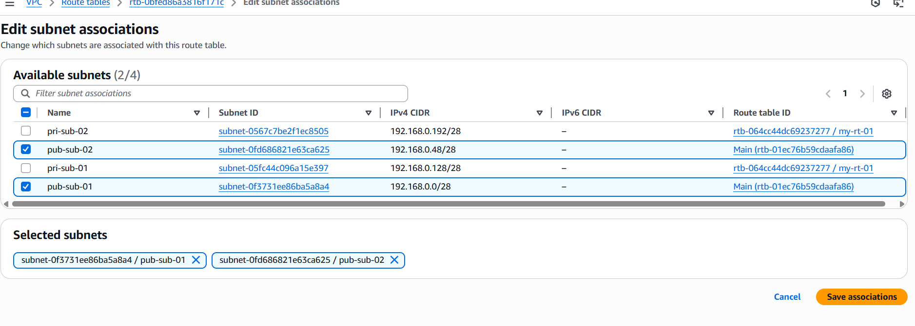

**6.Public route table will have the routes to internet and local**.

We have give the internet access to public route create internet gateway.

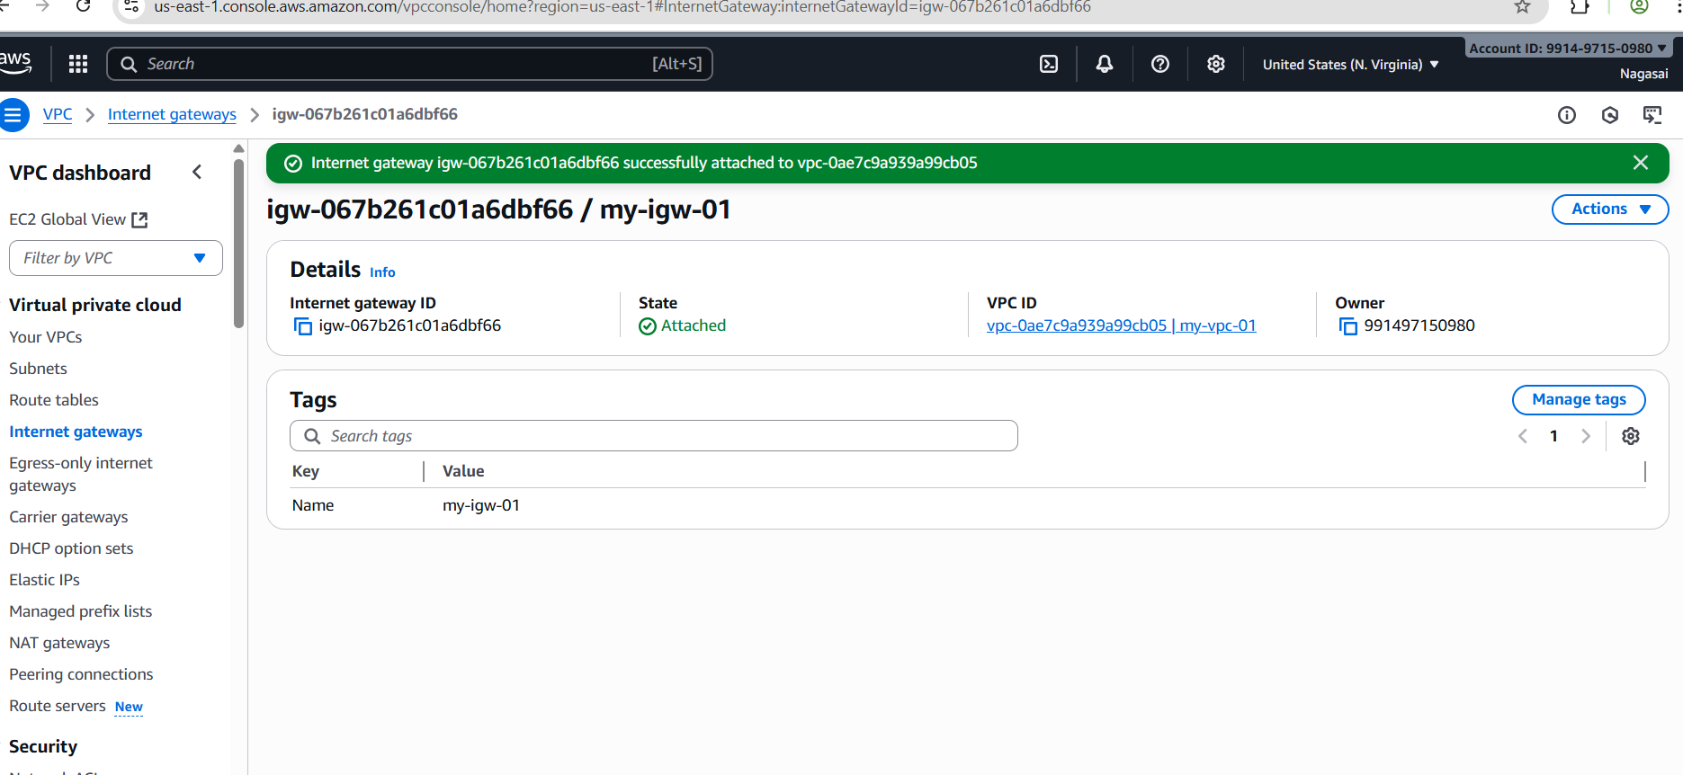

And add internet gateway to private route tables.

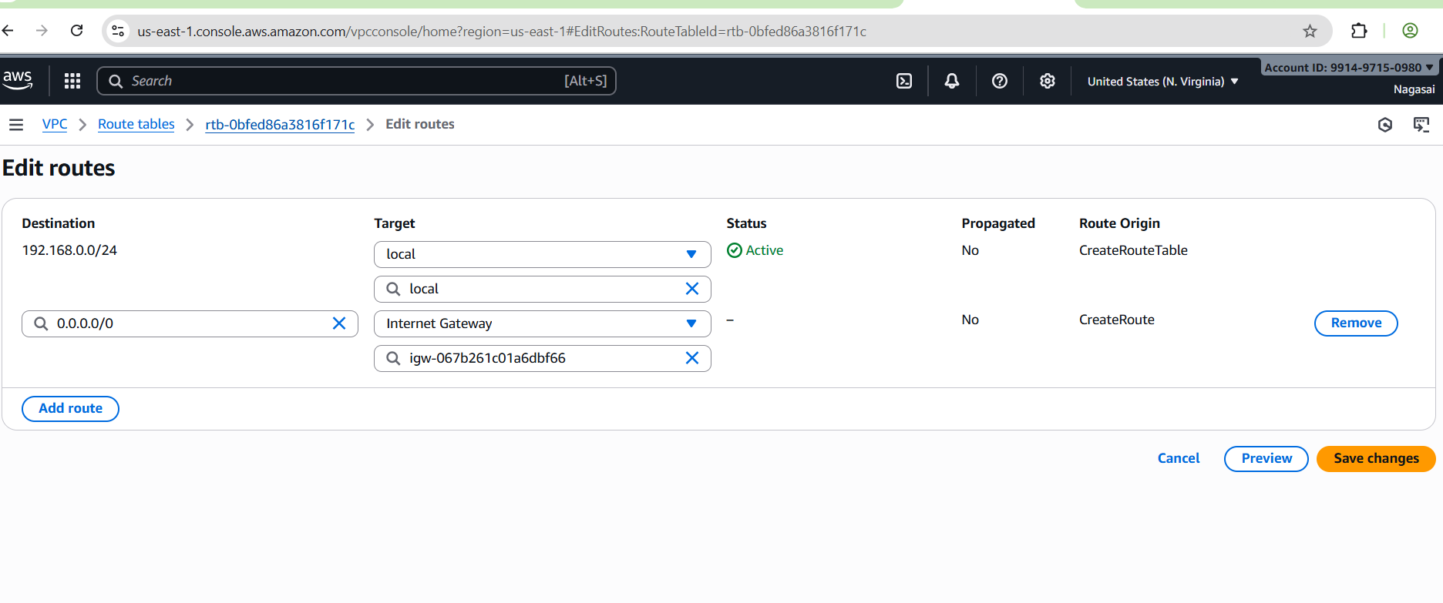

**7.Create EC2 in public subnet with t2.micro and install PHP**.

Go to ec2 services 🡪 add name 🡪select an ami🡪select t2 micro.

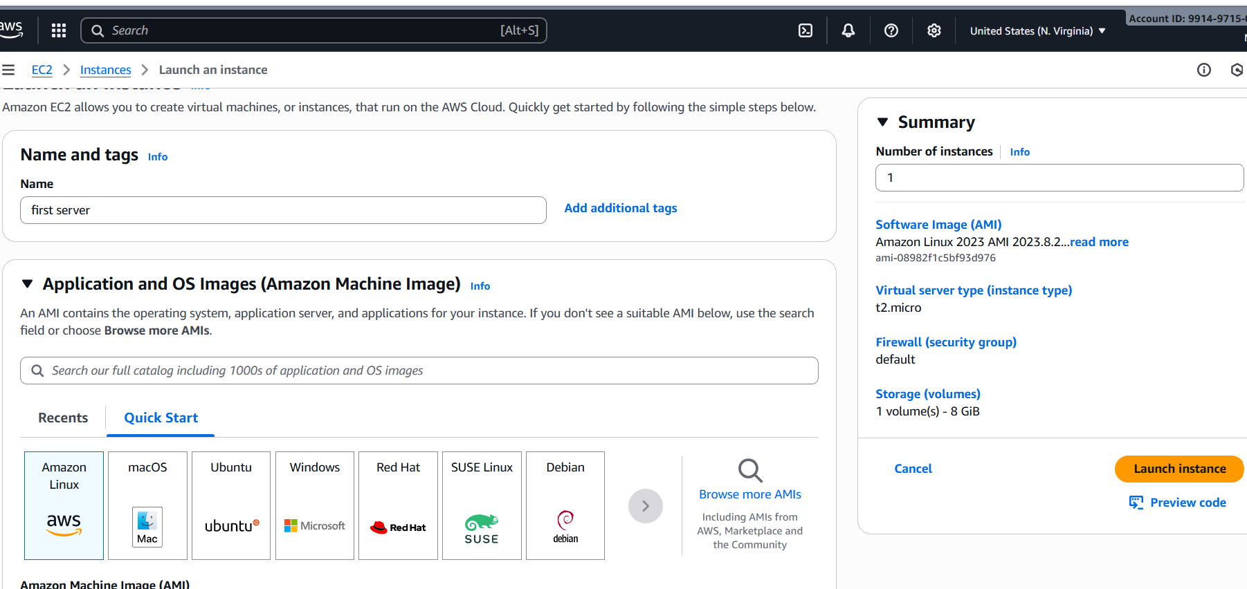

Add existing key pair or create new key pair🡪select vpc🡪add public subnet-🡪 launch instance.

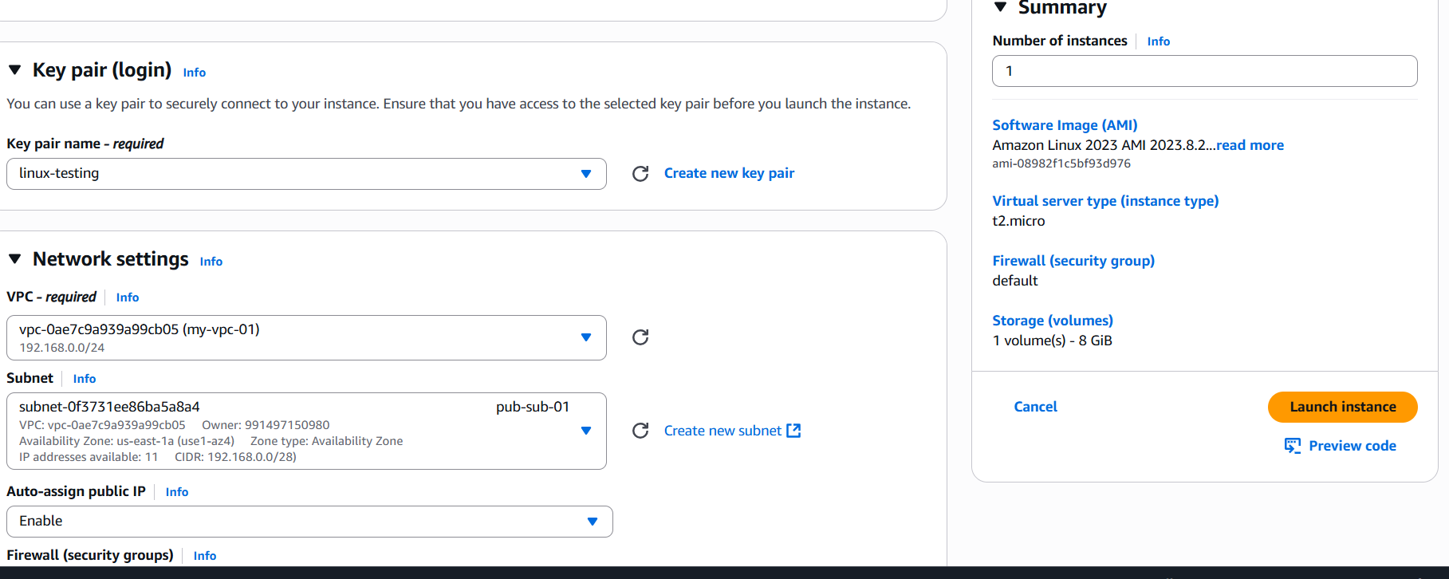

Successfully launch an instance.

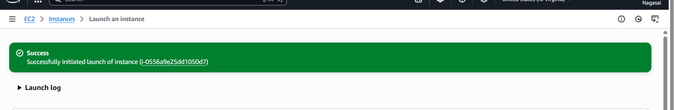

Yum update -y

sudo yum install -y php php-cli php-mysqlnd => use this command for install for PHP

echo "<?php phpinfo(); ?>" | sudo tee /var/www/html/index.php=>

systemctl start httpd

systemctl enable httpd

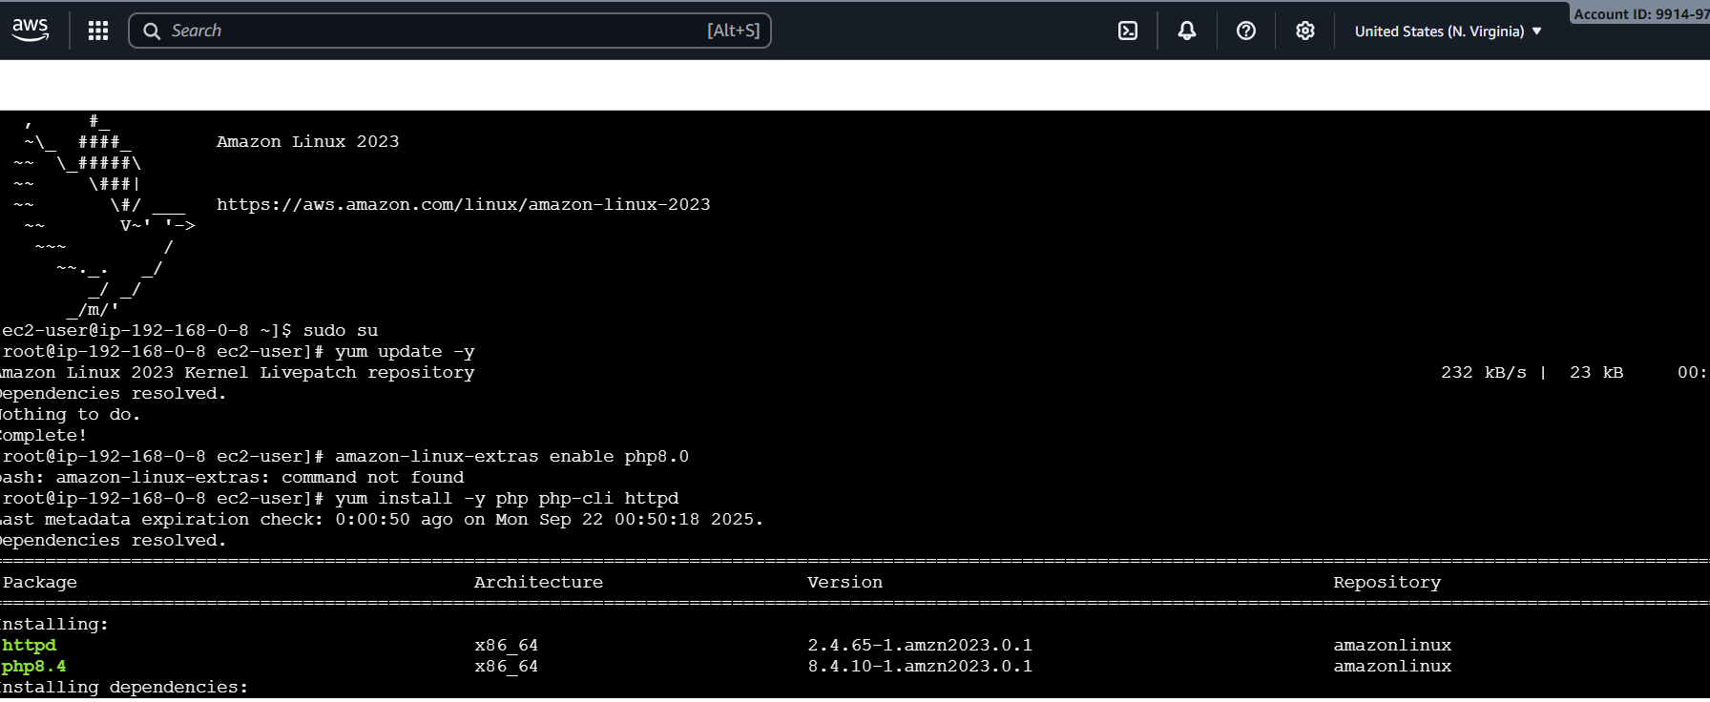

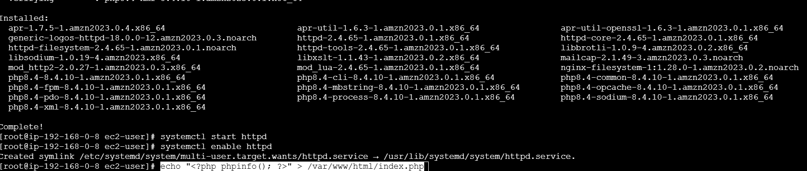

Go to browser and enter https:public ip:80.

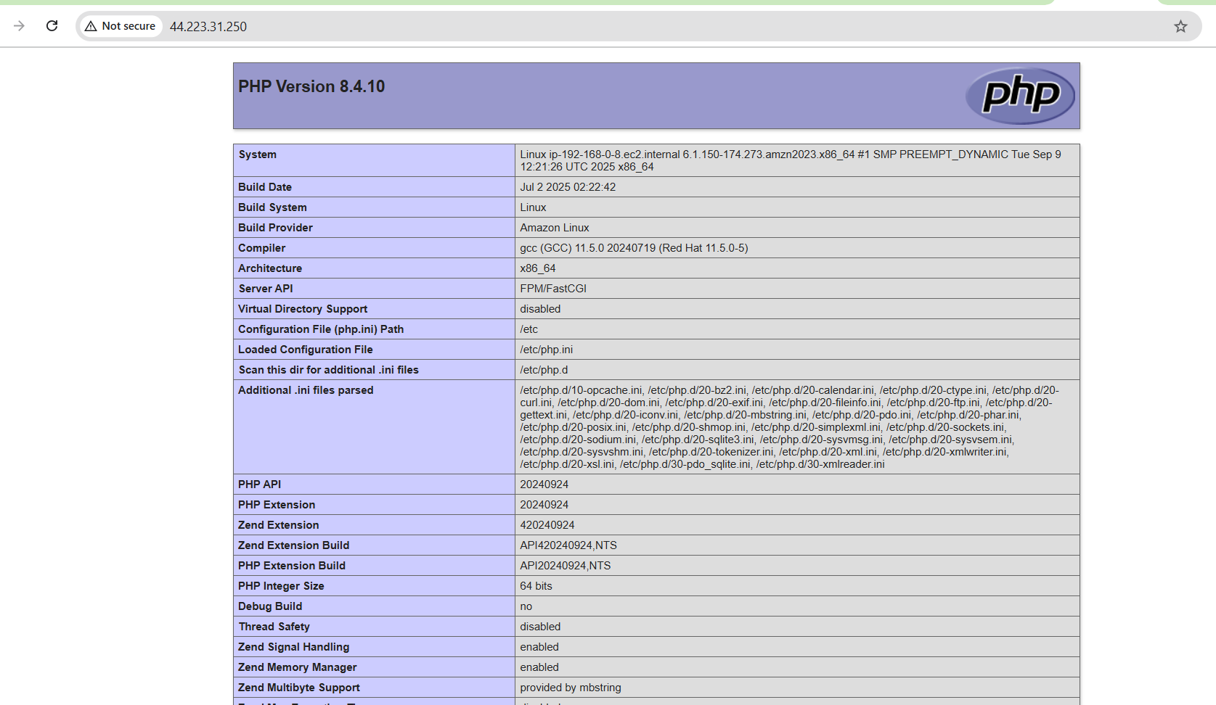

**8.Configure NAT gateway in public subnet and connect to private instance.**

Go to VPC → NAT Gateways → Create NAT Gateway.

1. **Subnet**: Choose one of your **Public Subnets** (e.g., 192.168.0.0/26).
2. **Elastic IP**: Allocate a new Elastic IP and select it.

Click **Create NAT Gateway**.

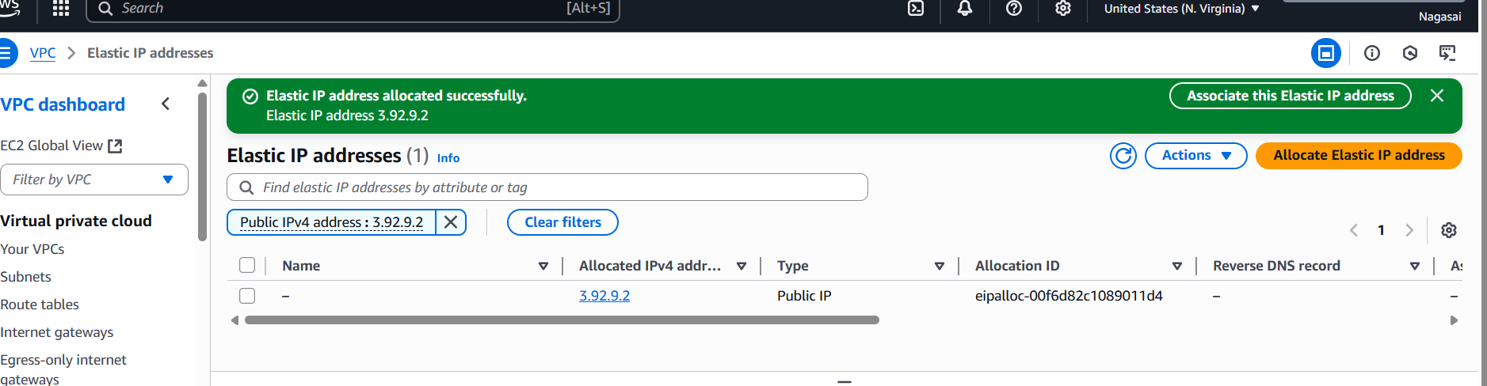

**Update Private Route Table**

Go to **VPC → Route Tables**.

Select your **Private Route Table** (associated with your 2 private subnets).

Go to **Routes → Edit routes** → Add:

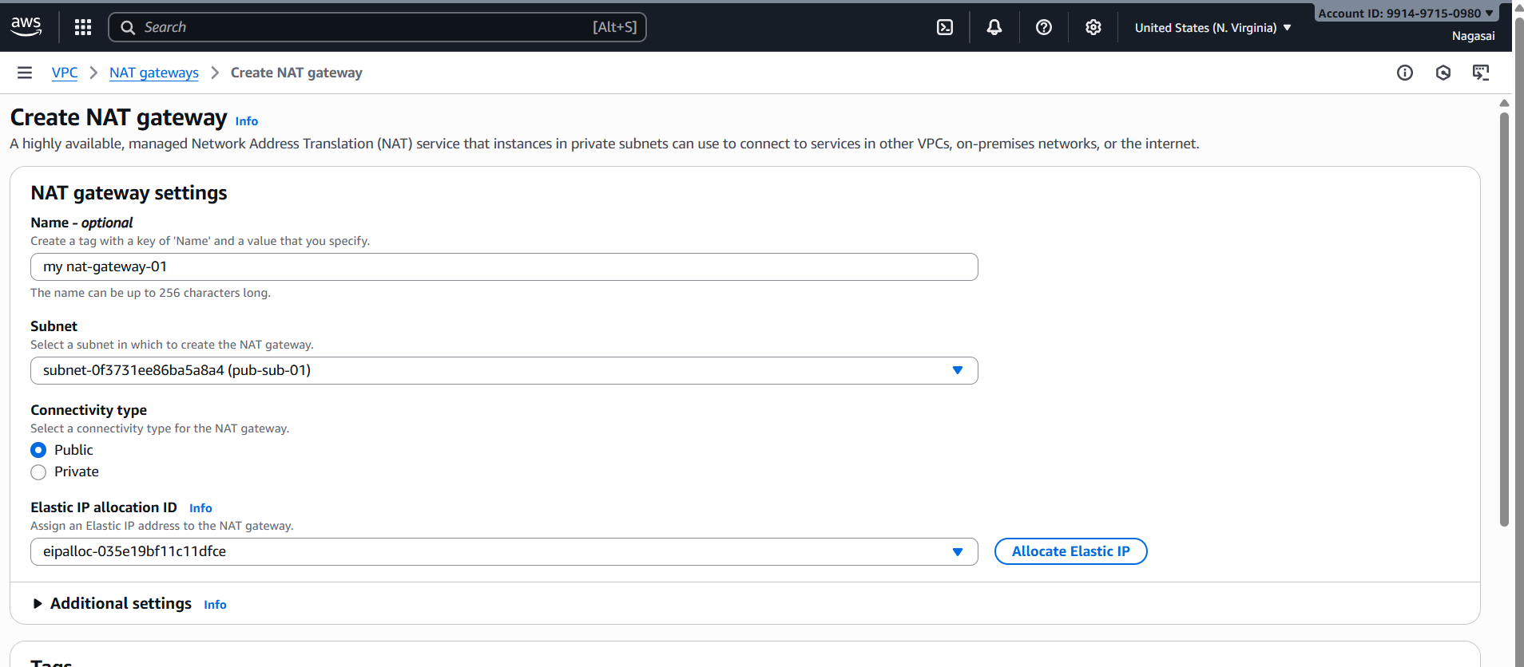

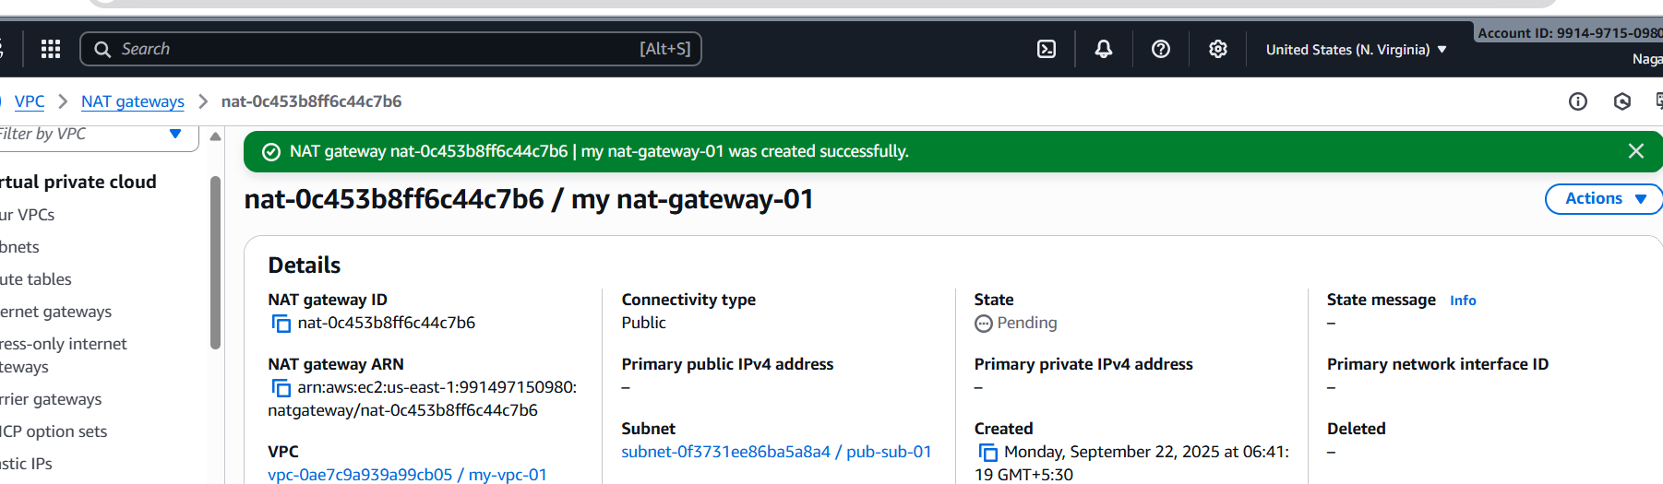

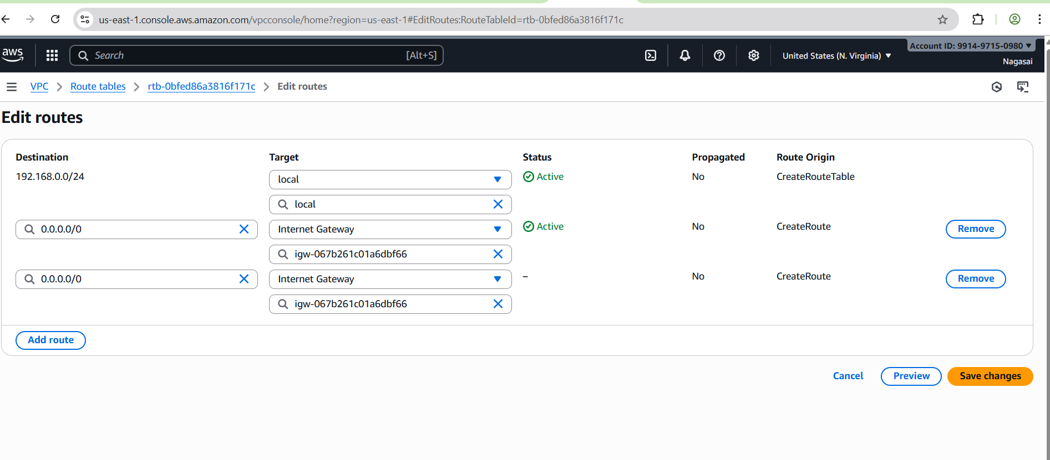

**9.Install Apache Tomcat in private EC2 and deploy a sample app.**

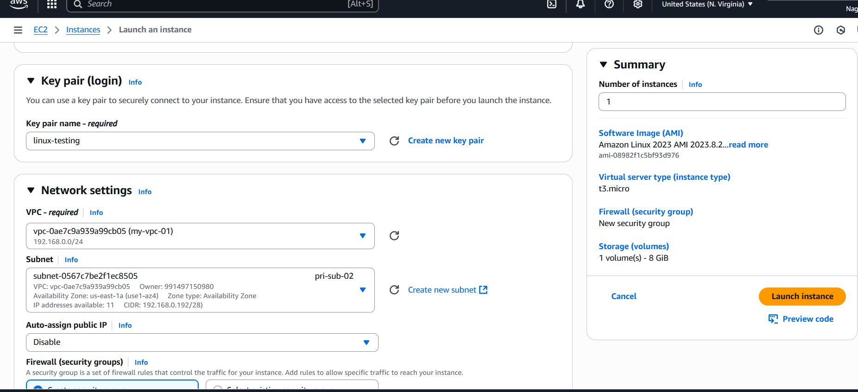

Configure VPC flow logs and store the logs in S3 and CloudWatch.